English lessons for Urban Engineering Students: 2nd Year Students (G1)
Teacher: DilmiCheyma

Terminologies:
Urban Basic Services (UBS) = الخدمات السياسية للمدن
Urban Agriculture= الزراعة الحضارية
Urban Center= مراكز حضارية
Urban Commercial Use= الاستخدام الحضاري التجاري
Use of Urban Residential [civil engineering] =الاستخدام الحضري السكني
Adequate Distribution= التوزيع الكافي او الملائم
Analytical Map= خريطة تحليلية
Arable Land= ارض صالحو للزراعة
Use of Urban Service [civil engineering]=الاستخدام الحضري الخدمي
Social or Urban Indicators {civil engineering]=المؤشرات الاجتماعية او الحضرية
Urban renewal [general]=التجديد الحضري
Urban schools [general]=المدارس الحضرية
Urban slums [general]=الأحياء الفقيرة الحضرية
Urban studies [general ]=دراسات مدينيه
Urban Development:
Urban and Suburban Development= التنمية الحضارية و تنمية الضواحي
Urban Administration and Urban Development= ادارة التنمية الحضارية

Housing and Urban Development= وكالة الاسكان و التنمية الحضاري
Urban Development Unite= وحدة التنمية الحضارية
Scientific Terminologies:
Urban Demography= علم سكان الحضري
Urban Ecology= البيئة الحضرية
Urban Ecosystem= نضام بيئي حضري
Agronomist(Agronomy)=خبير زراعي
Urban Education= تعليم الحضري
Urban Environment= البيئة الحضرية
Urban Geography= الجغرافية الحضارية
Urban Extension: الامتداد الحضري

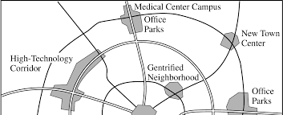

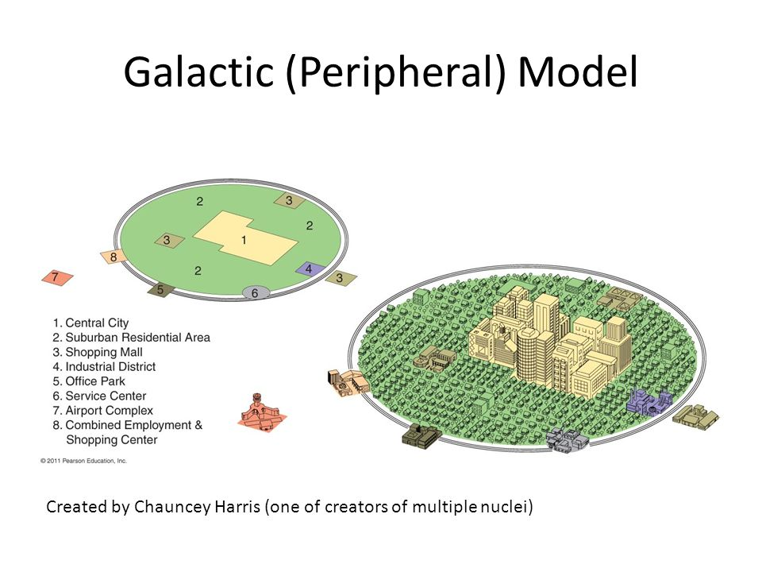
How to build a House?
What is inside the house? Guess! Let’s open the door and tackle the details of the house above.
As an urban engineer you can design the house according to the design or the plan you were provided.

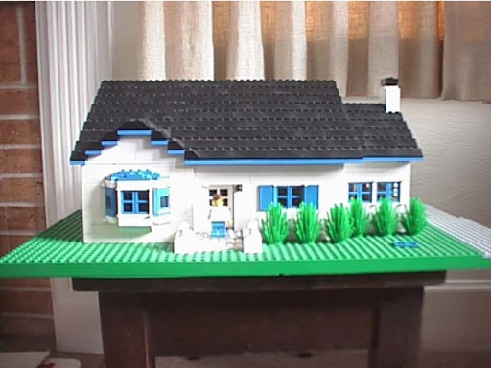
- Corridors or Alleys
- Rooms : living-room, bed-rooms, kitchen, bath-room, dining-room
- Roofs, grounds, doors and windows
- The house can be divided into: upstairs and downstairs, what is between them called “stairs”
- What is outside the house? : Garden, trees, grass, or lake (real or superficial lake), and sidewalk (pavement)

